Insight Meditation Center

Labor Day Family Retreat
for K to 5th Graders & Parents
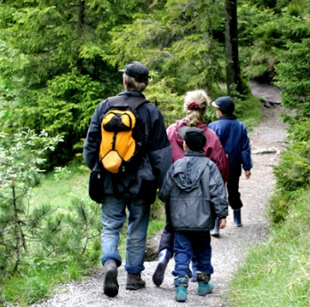

Noon Sat. Sept. 1 to Noon Mon. Sept. 3, 2018
at Jikoji Zen Retreat Center

Enjoy a weekend of Family Practice, Parent Practice, Hiking, and Community.

We invite you to join us! During this weekend we will meditate together as families, as well as in separate groups for adult caregivers and children. There will also be plenty of time to explore our diversity in a kind and welcoming way, share our cultures and family traditions, enjoy hiking, arts and crafts, and spend free time relaxing outdoors. Everyone will also share in doing simple chores.

Jikoji is a rustic Meditation Center in the middle of an open space preserve off Skyline Blvd. in the Santa Cruz Mountains. Accommodations are camping and shared dorm rooms. Vegetarian meals will be provided.

Forms for registration by lottery will be available online:
Follow the link from the IMC home page under “What’s New” or go directly to: http://www.insightmeditationcenter.org/programs/youth-children/

There is no cost for this retreat. Dana (donations) are welcome.
Contact Liz Powell for more information at eapowell@aol.com

