Insight Meditation Center
Memorial Day Family Retreat
K-5th Graders & Parents
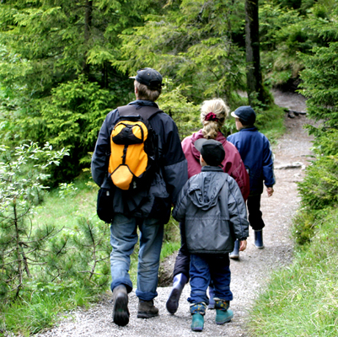
Noon Sat. May 24 to Noon Mon. May 26, 2014
at Jikoji Retreat Center
Richard Shankman & Rebekkah LaDyne

Enjoy a weekend of Family Practice, Parent Practice, Hiking, and Community.

During this relaxed weekend we will gather for teacher-led family practice periods and parent practice periods as well as special groups for the children. We will alternate between structured retreat practice, hiking, crafts and small group sharing circles.
Everyone will also lend our hands to simple chores to help with the retreat.

Jikoji is a rustic Zen Center in the middle of an open space preserve off Skyline Blvd. in the Santa Cruz Mountains. Accommodations are camping and shared dorm rooms.
This is sure to be a memorable weekend for the whole family. Join us!

Forms for registration by lottery will be available online:
Follow the link from the IMC home page at: http://www.insightmeditationcenter.org/ under “What’s New”

There is no cost for this retreat. Dana (donations) are welcome.
Contact Liz Powell for more information at eapowell@aol.com.

