Insight Meditation Center

Memorial Day Family Retreat in English & Spanish
(vea el otro lado para versión en inglés)
for K-6th Graders & Parents
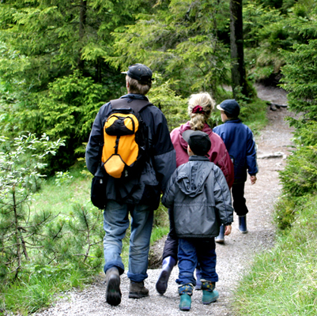
Noon Sat. May 28 to Noon Mon. May 30, 2016
at Jikoji Zen Retreat Center

with Richard Shankman, Andrea Castillo, Liz Powell & Bruni Dávila

Enjoy a weekend of Family Practice, Parent Practice, Hiking, and Community.

We invite you to join us! During this weekend we will meditate together as families, as well as in separate groups for parents and children. There will also be plenty of time to enjoy hiking, arts and crafts, and spend free time relaxing outdoors. Everyone will also share in doing simple chores.

Jikoji is a rustic Meditation Center in the middle of an open space preserve off Skyline Blvd. in the Santa Cruz Mountains. Accommodations are camping and shared dorm rooms. Vegetarian meals will be provided.

Forms for registration by lottery will be available online:
Follow the link from the IMC home page at: http://www.insightmeditationcenter.org/ under “What’s New”

There is no cost for this retreat. Dana (donations) are welcome.
Contact Liz Powell for more information in English at eapowell@aol.com, and
Bruni Dávila for information in Spanish at brunidp@gmail.com

